Hyperparameter Tuning

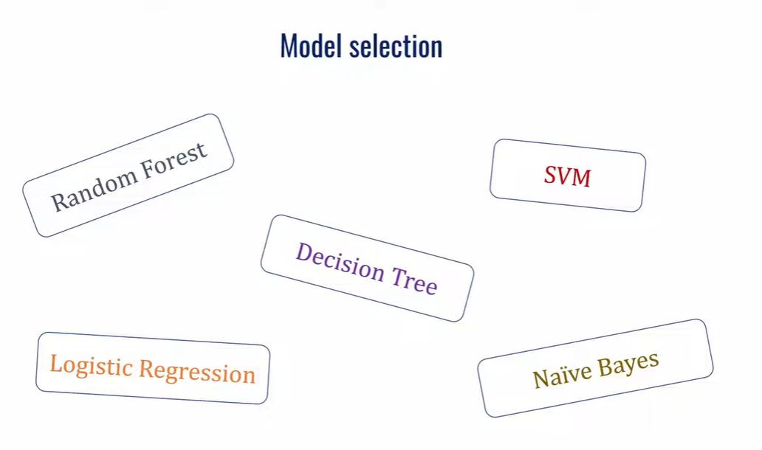

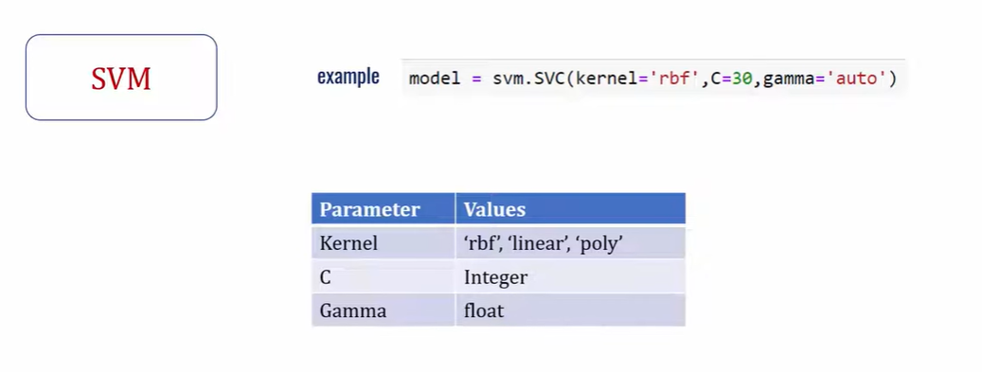

GridSearchCV and RandomSearchCV
CV – Cross Validation

Test
Train
Input Data

70 30
Test

Data of 100 rows
1, 2, 3, 4………100
5 buckets of 20 rows. 1 bucket of 20 rows will become test each time and others will become training
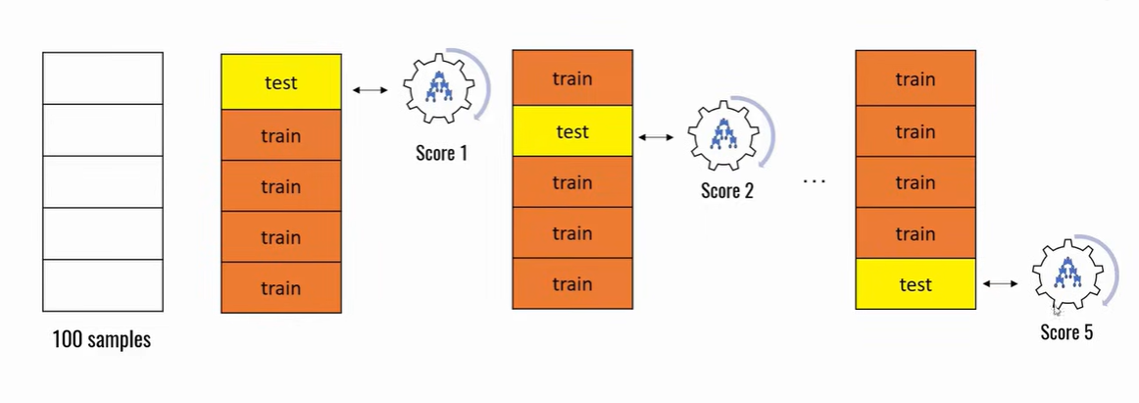

RandomForest
2 parameters – Max_Depth, No of Trees, Criteria

